WAVE-PIERCING BOW TECHNOLOGY EXPLAINED
by Gregor Tarjan
photo: Billy Black

Wave-piercing bows - or reverse or hammerhead bows are part of today's cutting edge naval architecture and the latest thinking in go fast comfort. Versus conventional overhanging or straight stem bows, wave-piercing bows are reversed and are designed to cut through waves, increase performance by reducing pitch resistance. The added benefit is not only higher speeds but a much more comfortable motion at sea.

There are several reasons to consider designing a boat with reverse rake bows. The primary rationale why we consider this hull shape is to reduce pitching motion caused by waves of certain amplitude and frequency. I think an easy way to explain it is this: Assume you are sailing along in smooth water with a conventional shaped hull with no pitching motion. Along comes a single wave. As your bow starts to penetrate into the wave, you pick up buoyancy in the overhanging bow region. The boat reacts to this increase in buoyancy by pitching bow-up. As the wave passes under the boat, the bow then must fall back to equilibrium. The more reserve buoyancy the wave sees as the bow penetrates through the wave, the more pitching moment is imparted onto the boat by the wave and the greater the potential for pitching motion. So if your bow has a lot of overhang or flare (vertical angle of the hull sides), then you naturally have a lot of reserve buoyancy high up in the bow region and this may result in excessive pitching motion. Of course the downside to a reverse -wave piercing bow might be a slightly wetter ride on a small multihull such as a beach cat, but on cats larger than 35' this is hardly an issue.

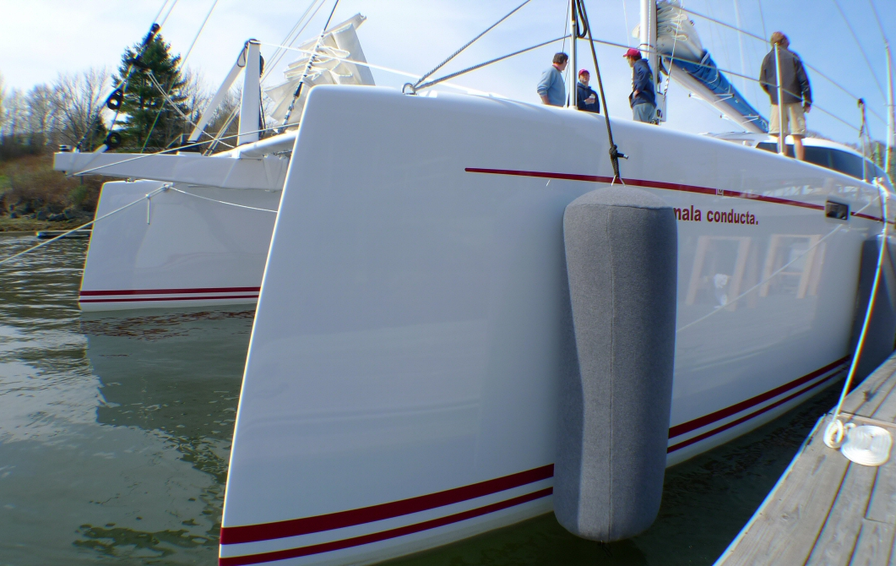

Morrelli & Melvin designed 62' catamaran

Why do we care if the boat pitches? Because pitching increases hull resistance, reduces the efficiency of the rig and underwater foils due to unsteady flow, and causes motion discomfort for the people on the boat. In order to keep the boat from pitch poling (or turning back over front), you need a certain amount of buoyancy forward. On a wave-piercing type bow, this buoyancy and lift are achieved by making the hull fuller down low. On some wave piercing designs, the hull is wider at the waterline than at the deck, especially near the bow. The wider, flatter underwater shape provides lift at high velocities and dampens pitching at all speeds. Other benefits of wave piercing bows are reduced weight and wind age. You can really feel this difference on medium displacement and light weight multihulls. The older designs with tall bows get pushed around in higher wind and sea states whereas the newer wave piercers are easier to steer and maneuver in waves.

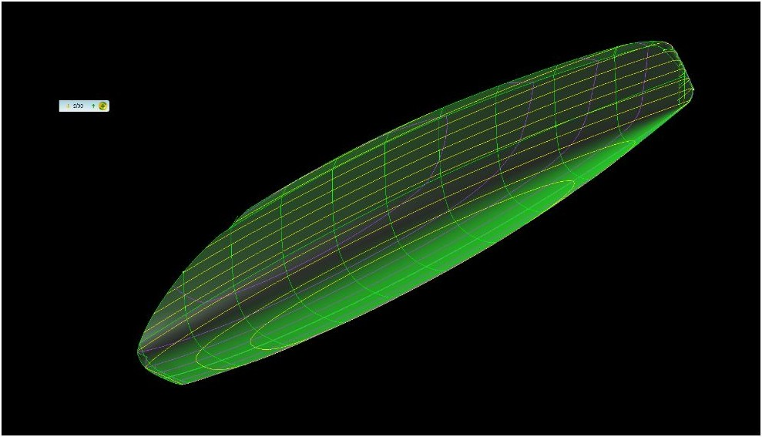

the new Aeroyacht ALPHA 42 catamaran

Variations of these shapes are now making their way into some larger racing and cruising designs - such as our own, all new Aeroyacht Alpha 42' cruising catamaran and the giant Aeroyacht 85', 110' and 125' catamarans. Other boats worth mentioning are the Morrelli Melvin 62' and 65', the Catana 50', the Outremer 45' the advanced Neel 45' and 50' trimarans and some of the newer Sunreef custom catamarans. The faster and longer your boat, the more sense reverse bows make. Today even America's Cup racing yachts all feature reverse bows and they are definitely part of our boating future.

For more information visit: www.Aeroyacht.com or email Gregor Tarjan at gt@aeroyacht.com

